Shared IMS Design Alignment and Detailed Core MVP Prototype
UX deliverable — Sprint 1
Team: Team 40 / Team B — Intern Management System
Task: [UX DESIGN] — Shared IMS Design Alignment and Detailed Core MVP Prototype
UX Designer: Faridullah Jabbar Khil
Sprint: Sprint 1 — Design & Bootstrap
Due date: 10 September 2026 (extended per Team A/B Sprint 1 Playback Preparation Meeting, 9 September)
1. Purpose
This document records the work completed against the 11-item checklist for this task: reviewing Team A's shared Figma conventions, aligning Team B's prototype navigation and component styling to match, and completing all four Core MVP flows as a single interactive prototype. Screenshots throughout are rendered directly from the working prototype code — not mockups.
2. Checklist status
# | Item | Status
1 | Review Week 3 Validation and Sprint 2 Readiness Coordination Record | Not reviewed — document not yet provided
2 | Review existing Team B requirements, wireframes and prototype | Done
3 | Review Team A shared Figma/design conventions | Done — queried Team A's live file directly via Figma MCP
4 | Align shared visual, navigation, form, button and interaction patterns | Done — see Section 3
5 | Complete the Mentor Task Assignment flow | Done
6 | Complete the Intern Assigned Task / Task Submission flow | Done
7 | Complete the Weekly Progress Submission flow | Done
8 | Complete the Mentor Progress Review flow | Done
9 | Ensure the relevant Core MVP flow is fully interactive and review-ready | Done — see Section 4
10 | Incorporate material BA updates received during parallel work | No new BA material received since the Detailed Wireframes corrections
11 | Prepare the final Figma prototype for Sprint 1 Playback / Sprint 2 reference | Published to Figma Make (see link)

3. Team A design alignment
Team A's shared Figma file (“Captsone wireframes”) was reviewed directly via the Figma MCP connector — not estimated from screenshots. The file has no formal design-token system (no color styles, one bound variable in the whole file), so alignment was done at the component level: the exact pixel, color, and typography values of their header and buttons were extracted and applied to Team B's prototype.
Element | Team A (measured) | Team B (before) | Team B (now)
Logo box | 71×71px, #d9d9d9, square corners | Padding-sized, gray-200, rounded | 71×71px, #d9d9d9, square corners
Avatar | 55px circle | 32px circle | 55px circle
Header text | 20px Inter Semibold, black, -0.4px tracking | 14px, gray, Medium | 20px Inter Semibold, black, -0.4px tracking
Header border | 2px solid #747474 (bottom) | 1px gray, all sides | 2px solid #747474 (bottom)
Primary button | #3f3d3d fill, 8px radius | Generic gray-900 | #3f3d3d fill, 8px radius
Secondary (“Back”) | #efefef fill, #9e9e9e border, 8px radius | Plain text link | #efefef fill, #9e9e9e border, 8px radius

Team A's numbered step-circle navigation (1→2→3→4) was deliberately not copied. Their flow is a linear application wizard; Team B's Intern and Mentor screens are independent destinations, not a fixed sequence, so a stepper would misrepresent how the product actually works. Team A's nav bar style (logo box + avatar/name dropdown, clean sub-nav row) was matched; the stepper pattern was not.
Figure 1 — Team A reference — Application Portal (screenshots provided by PM)
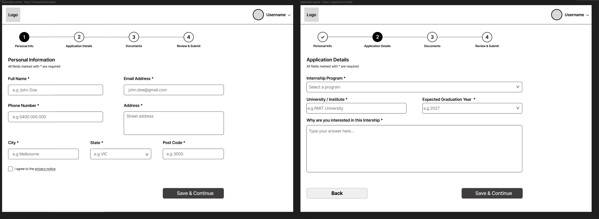
3.1 Update — PM feedback applied after initial submission
After the first version of this document, the PM confirmed two rounds of client feedback that changed the prototype materially. Both are reflected throughout this document and its screenshots — nothing below shows the earlier behavior.
- Task status is now 4 stages, not 3: Assigned → In Progress → Submitted → Completed. Submitting a task moves it to Submitted; Completed is now confirmed by the Mentor, not the Intern.
- Task Submission content is confirmed (Canvas-style): a description field and a file-attachment button. OR-03 is resolved and no longer shown as an open decision.
- Weekly Progress allows exactly one submission per week; the form locks after submitting. OR-01/OR-02 is resolved and no longer shown as an open decision.
- Mentor Progress Review is expanded with a new “Task Submission Review” section, showing the Intern's real submitted content and a “Mark Completed” action — not just static Weekly Progress text.
4. Prototype screens — all states
Every distinct screen and state in the prototype, in the order a user would naturally reach them.
4.1 Intern flow
Figure 2 — Intern Workspace
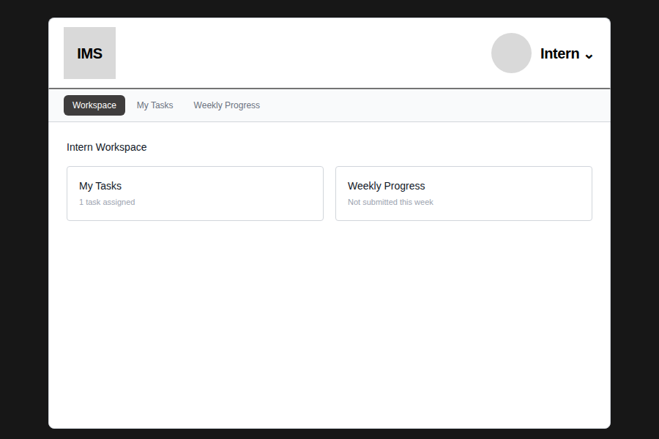
Figure 3 — My Tasks — task assigned
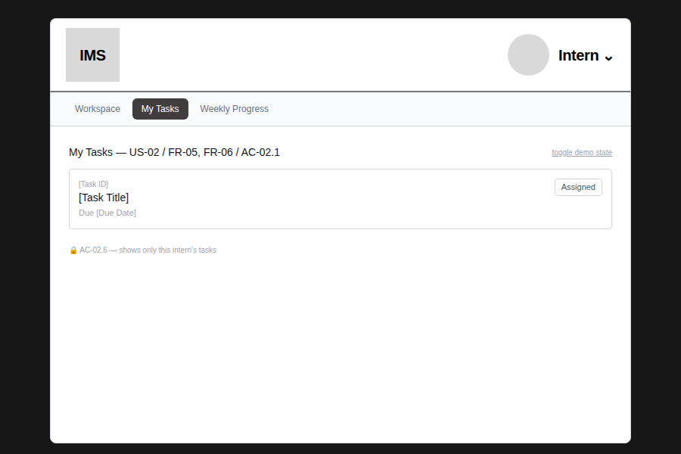
Figure 4 — My Tasks — no task assigned (EC-01 / AC-02.2)
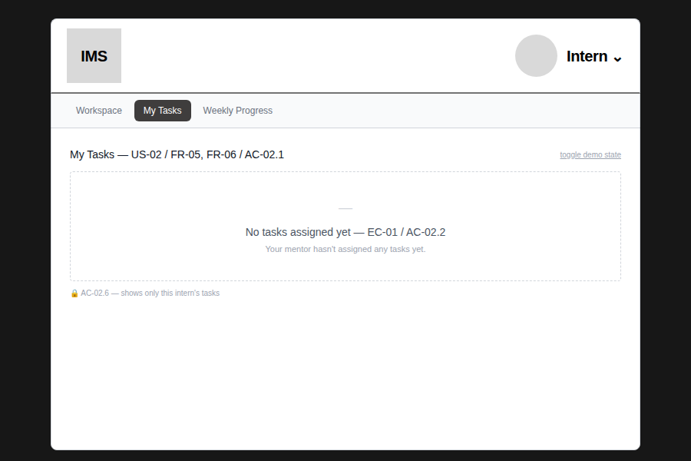
Figure 5 — Task Detail — Assigned
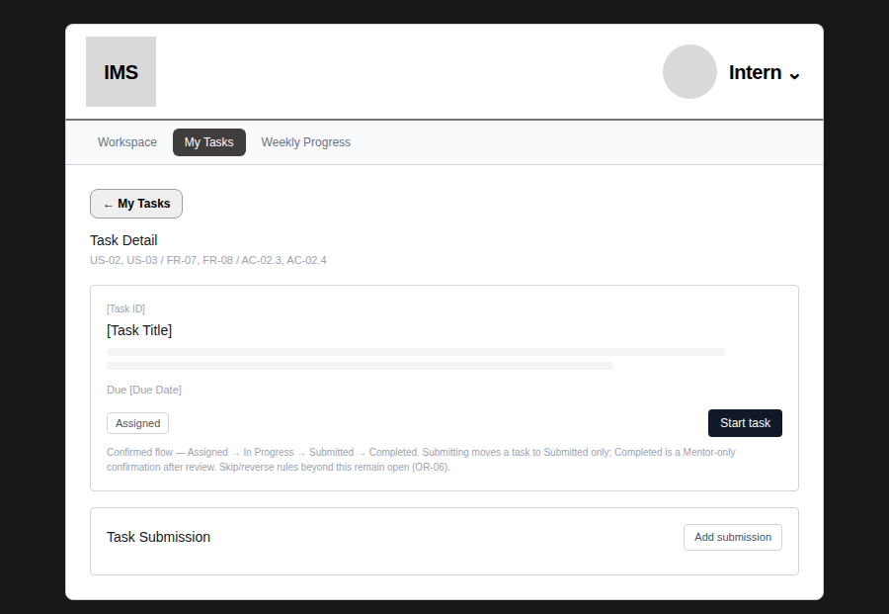
Figure 6 — Task Detail — In Progress (no self-complete option — see Section 3.1)
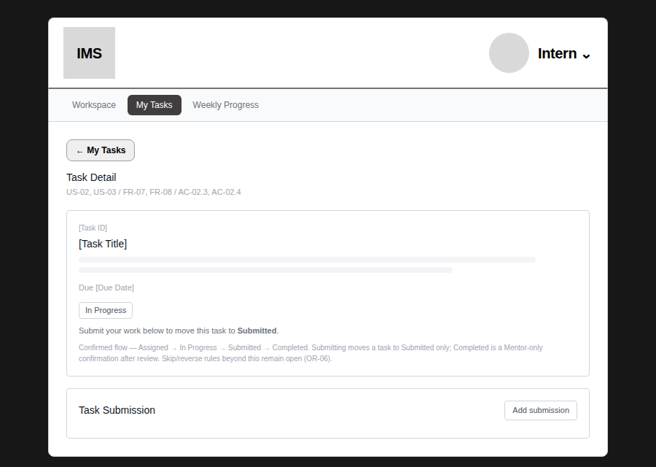
Figure 7 — Task Submission — form (confirmed fields: description + file attachment)
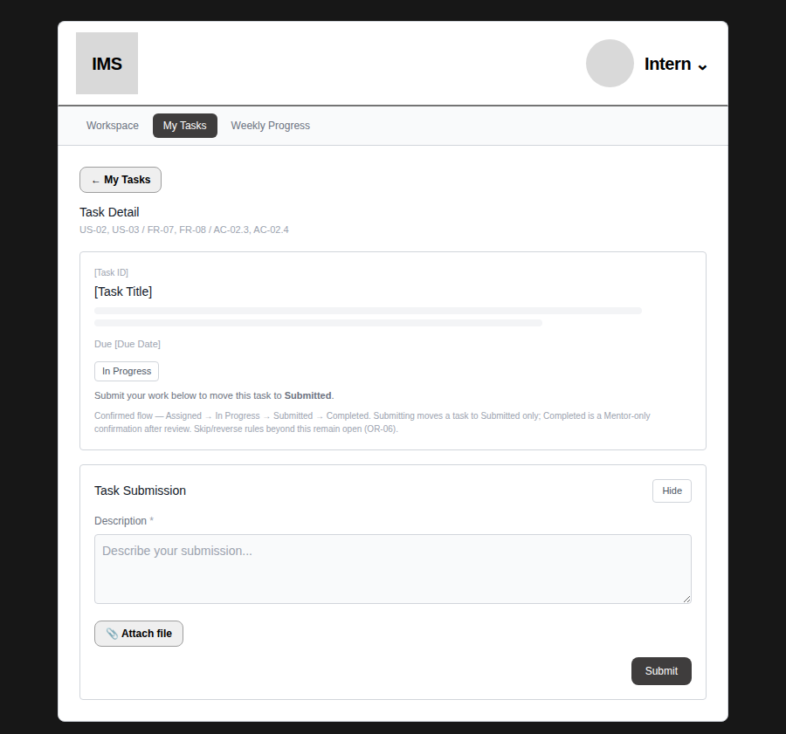
Figure 8 — Task Submission — submitted (status becomes Submitted, not Completed)
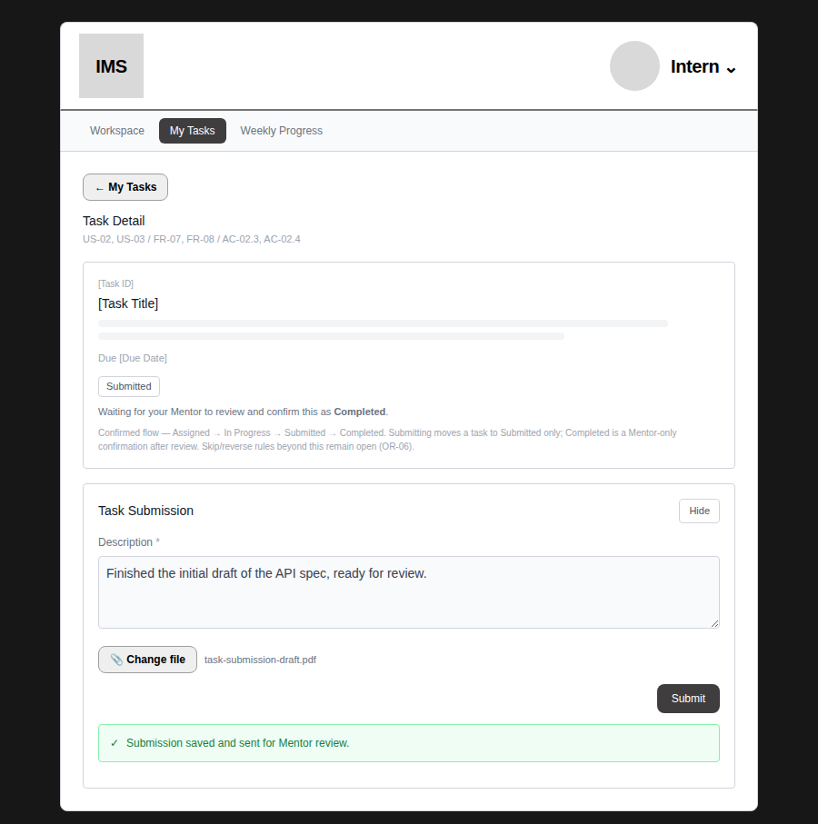
Figure 9 — Weekly Progress — form
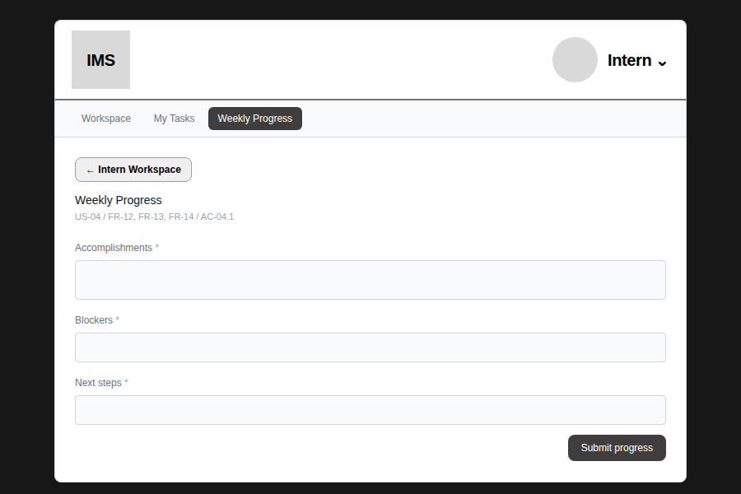
Figure 10 — Weekly Progress — locked after submission (one per week, WA-05)
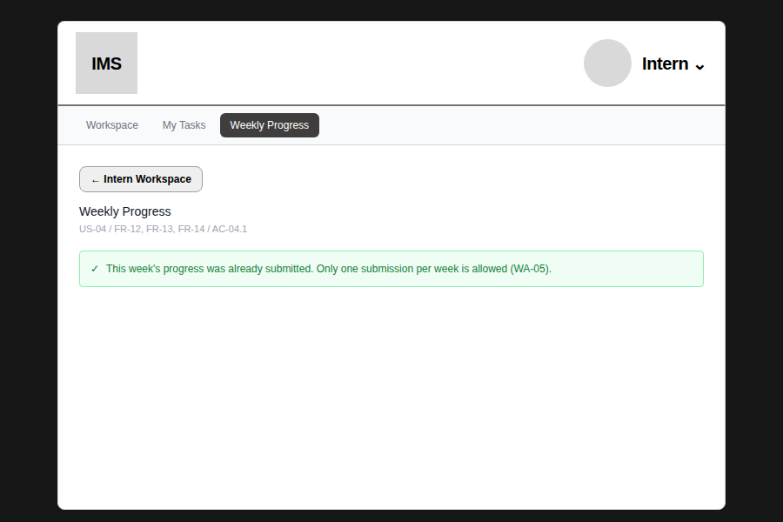
Figure 11 — Task Detail — Completed (confirmed by Mentor, reflected back to the Intern)
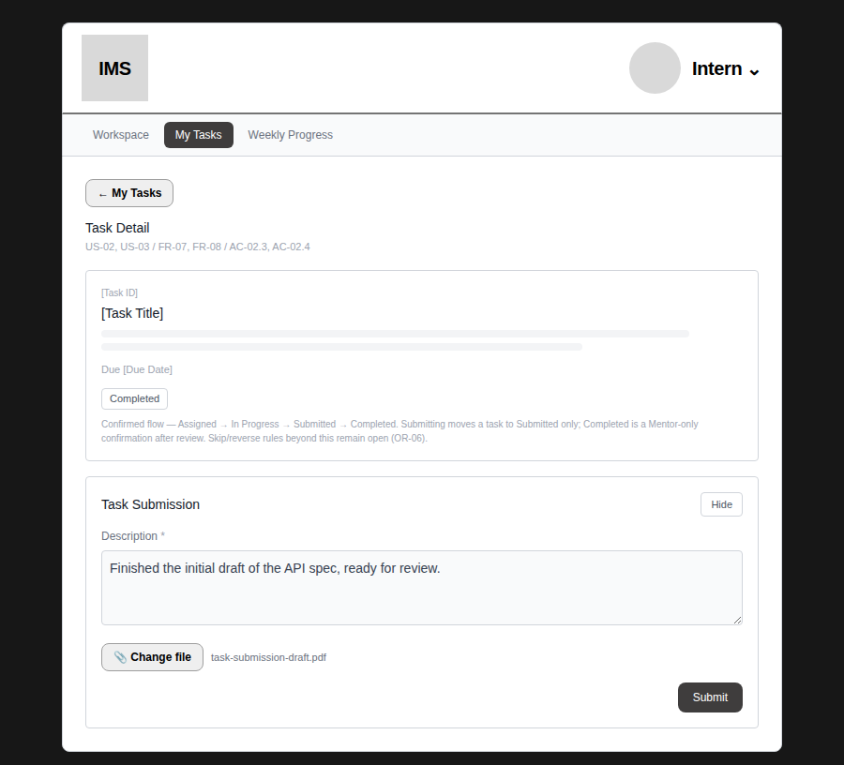
4.2 Mentor flow
Figure 12 — Assign Task — form
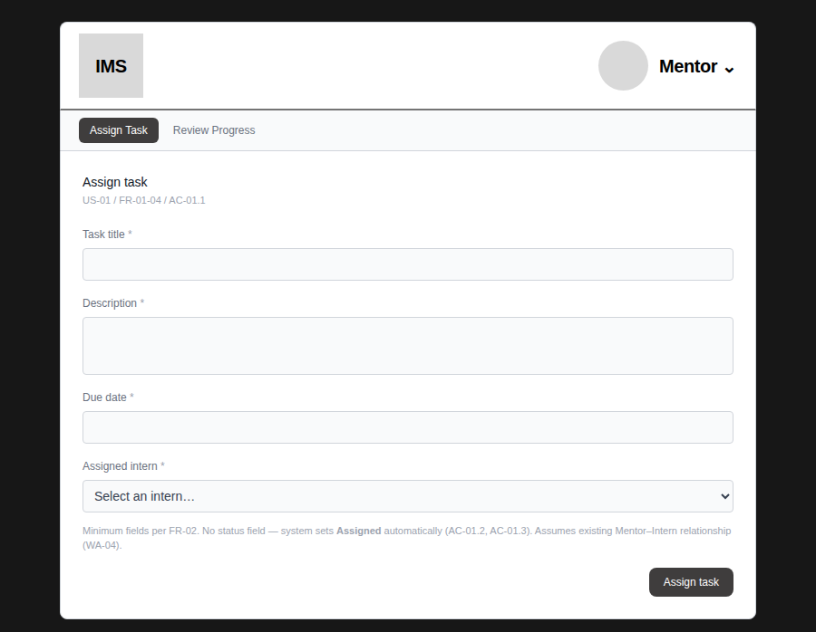
Figure 13 — Assign Task — intern selected
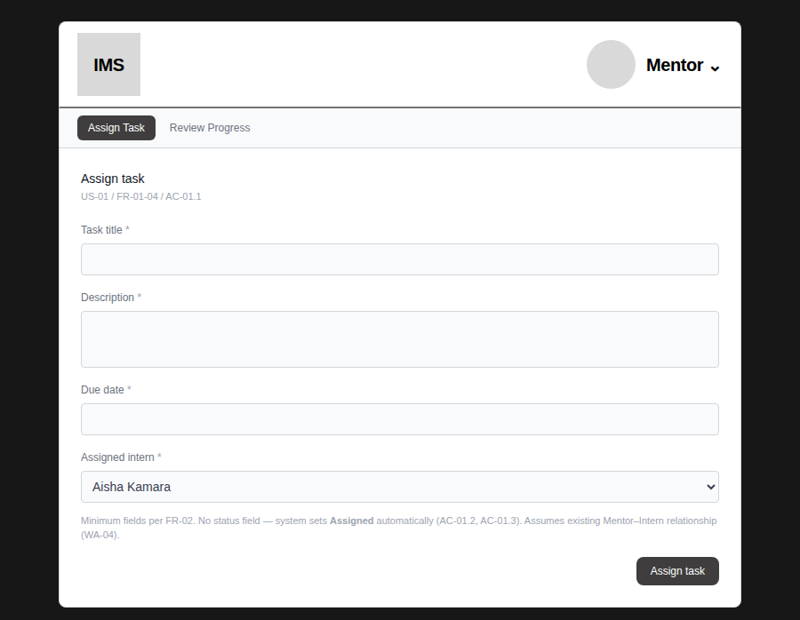
Figure 14 — Assign Task — success confirmation
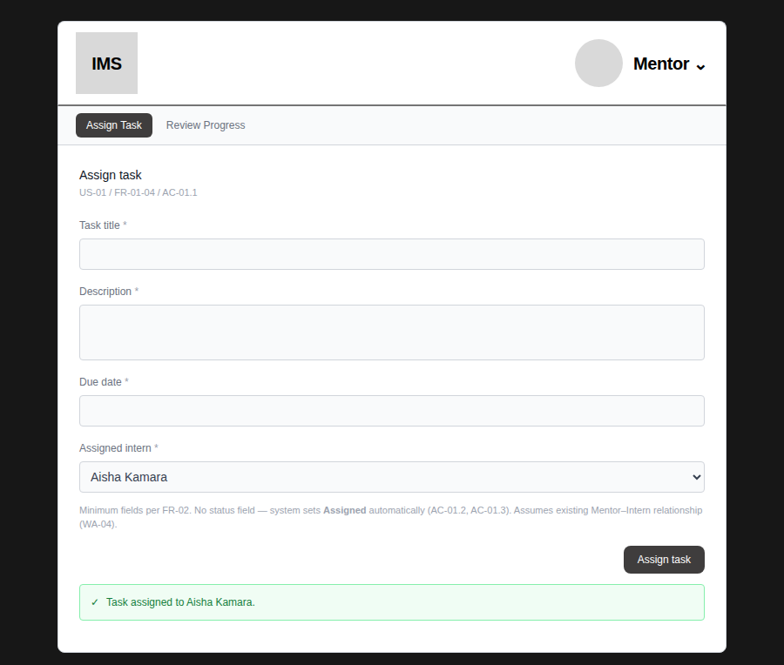
Figure 15 — Review Progress — Task Submission Review, not yet submitted
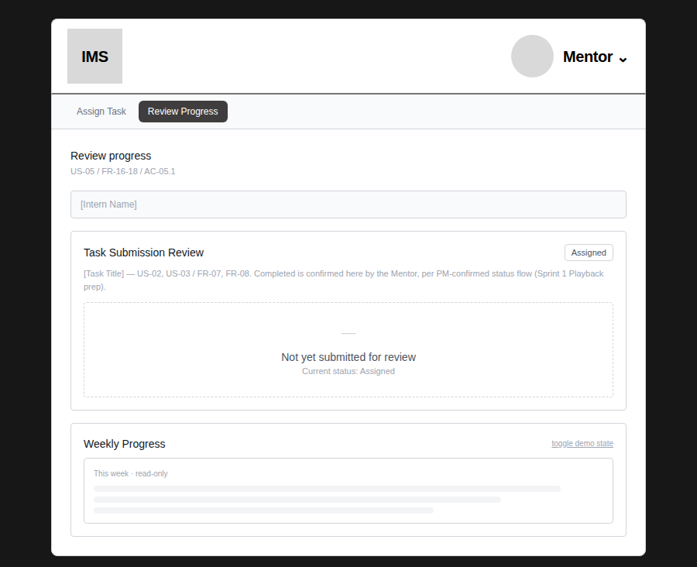
Figure 16 — Review Progress — Task Submission Review, showing the Intern's real submitted content
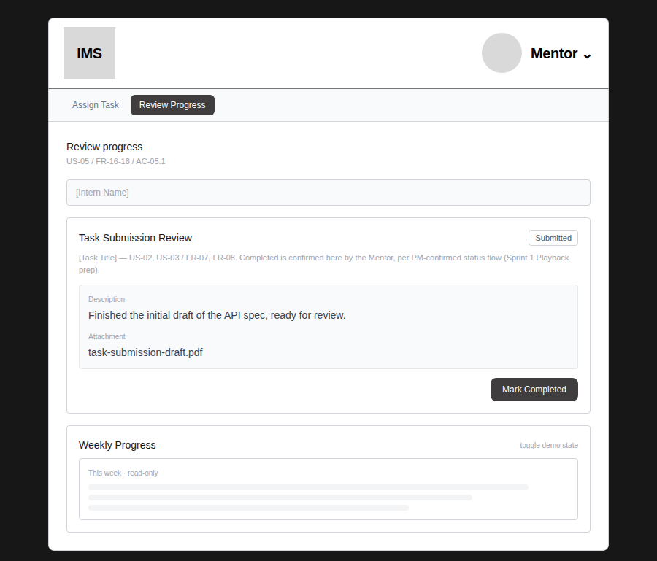
Description and file name shown here are the exact values entered on the Intern side (Figure 8) — not placeholders.
Figure 17 — Review Progress — after clicking “Mark Completed”
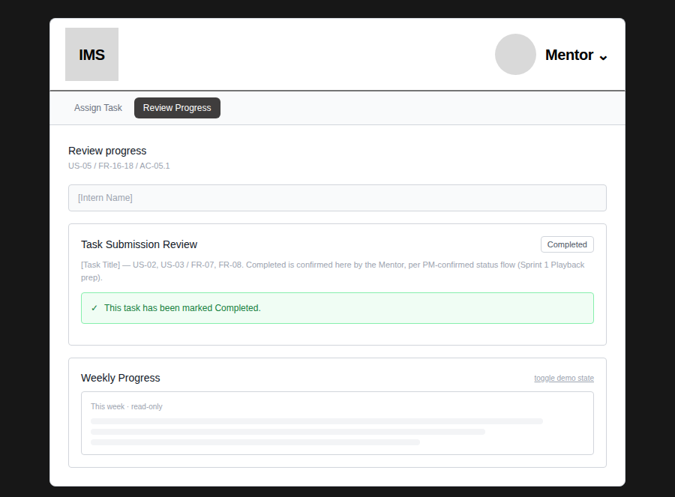
Figure 18 — Review Progress — Weekly Progress section, no submission (EC-09 / AC-05.2)
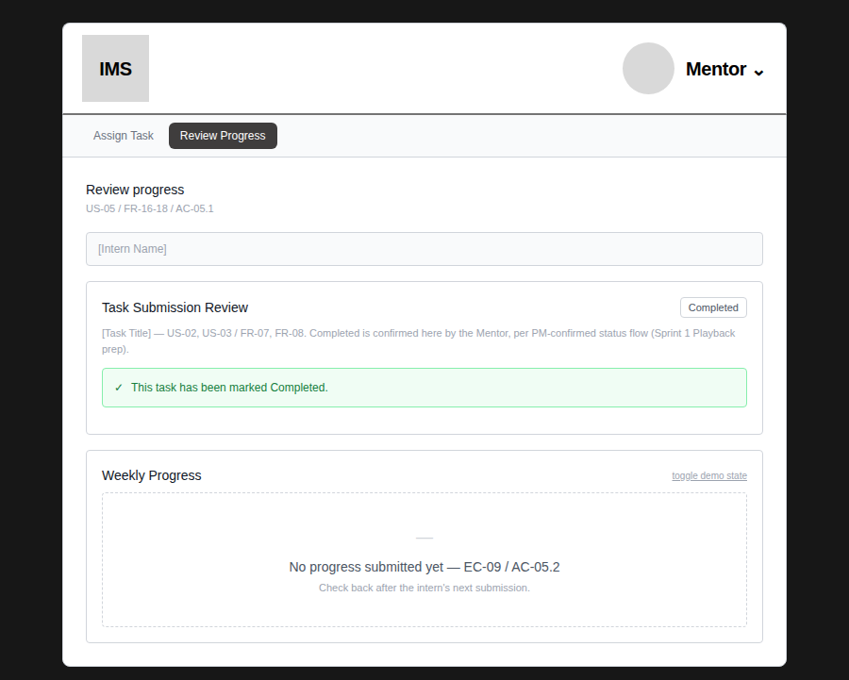
4.3 Shared / prototype tools
Figure 19 — Nav dropdown menu — role switch and prototype-only tools
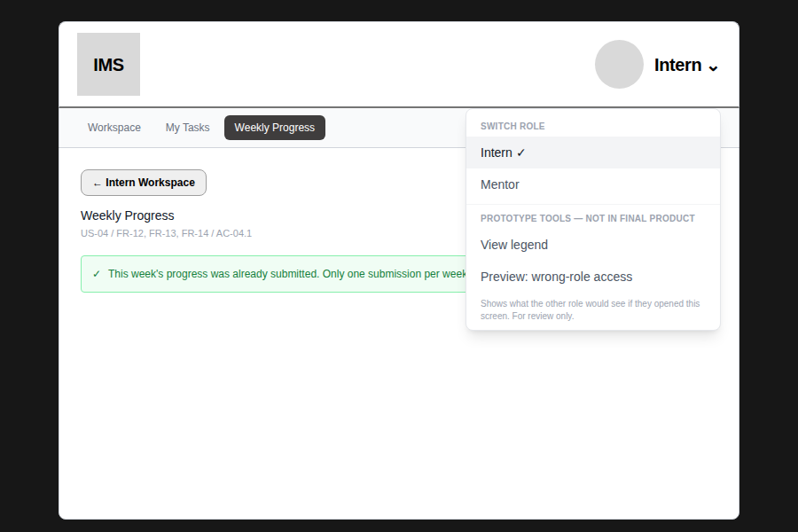
“View legend” and “Preview: wrong-role access” are labeled as review-only, not final-product features.
Figure 20 — Legend — key interactions and validation reference
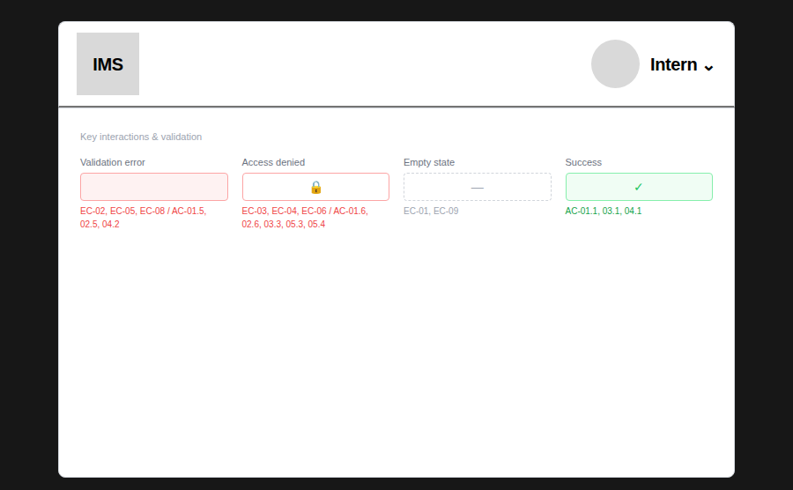
Figure 21 — Access denied — Intern previewing a Mentor-only screen (AC-05.3)
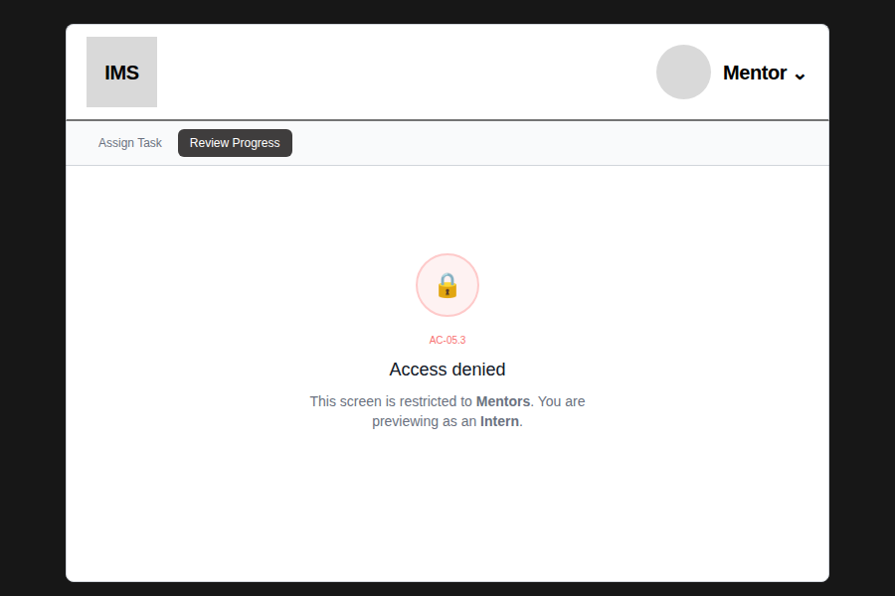
Figure 22 — Access denied — Mentor previewing an Intern-only screen (AC-02.6)
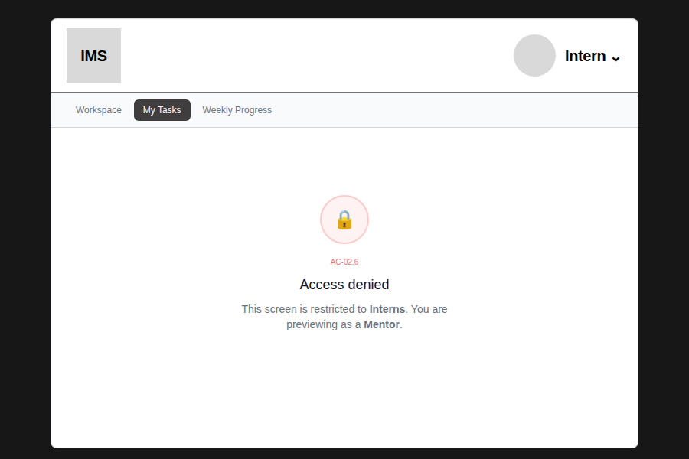
5. Notes and open items
- The Intern/Mentor role switcher and the wrong-role-access preview are review-only conveniences for this prototype stage. Neither will appear in the final product — role will come from the signed-in user's account, not a manual toggle.
- Item 1 (Week 3 Validation and Sprint 2 Readiness Coordination Record) could not be reviewed — this document has not been shared with UX. Please provide it if it affects scope.
- Who advances Submitted → Completed was inferred by reading the PM's two feedback messages together (the status-flow message implies a review gate; the following message asks to expand Mentor Progress Review). This has not been confirmed in a separate written requirement — please flag if a different design was intended.
- OR-06 (skip/reverse rules once a task reaches a later status) remains open — neither PM message addressed reversing or skipping stages, only the forward sequence and who confirms Completed.

